## VAV Terminal Minimum Airflow

### Author

Chris Balbach, PSD Consulting

### Description

This energy efficiency measure (EEM) changes the VAV box minimum flow setting to 0.4 cfm/sf for all airLoops in the model as per ASHRAE 90.1 standards. The given VAV box minimum airflow level represents the ASHRAE 90.1-2007 Appendix G prescribed benchmark for VAV minimum flow settings (Section G3.I.3.13 VAV Minimum Flow Setpoints). This setpoint is appropriate for most commercial office space settings but may not be applicable to model spaces having a high minimum ventilation rate.

### Modeler Description

This measure loops through the thermal zones in all air loops. It then selects the thermal zone area and then calculates the minimum flow rate of 0.4 cfm/sf. If the zone has an AirTerminalSingleDuctVAVReheat & AirTerminalSingleDuctVAVNoReheat terminal unit the measure changes the zone minimum air flow method to fixed flow rate and applies the calculated minimum flow rate.

### Use Case Types

New Construction, Retrofit, Model Articulation

### Arguments

No arguments

### Initial Condition Message

The model begins with {X} AirTerminalSingleDuctVAVReheat objects & {Y} AirTerminalSingleDuctVAVNoReheat objects.

### Final Condition Message

### "The model finished with {total number of air Terminal Single Duct} objects having the 'zone minimum air flow method' set to 'fixed flow rate' and a minimum airflow rate of 0.4 cfm/sf."

### Not Applicable Messages

* If No Air-loops write “Model has no airloops. Measure is not applicable” message.
* If there are airloops but no qualified air terminal objects then write “The building contains no qualified objects. Measure is not applicable” message.

### Warning Messages

### If the new cfm/ft2 value of 0.4 is greater than the existing value, a warning message including the name, object type, previous and new value(s) will be written.

### Information Messages

Write info message whenever a min airflow setting of any qualified object is changed. The message should include the name, object type, previous and new value(s).

### Error Messages

N/A

### Code Outline

1. Initialize variables needed for counting types of terminal units.
2. Loop through the demand side equipment for all airloops
   1. For each terminal unit of type (X, Y, Z, AA)
      1. Record the existing min airflow rate (cfm)
      2. Record the area of the companion thermal zone
      3. Calculate a new flow rate = 0.4 cfm/ft2
      4. Assign new min flow rate to qualified object.
      5. Write info or warning messages
3. Write initial and final conditions messages.

### Tests

Run this model against applicable prototype buildings and test against each qualified object type.

**This measure applies to:**

1. **Medium Office**

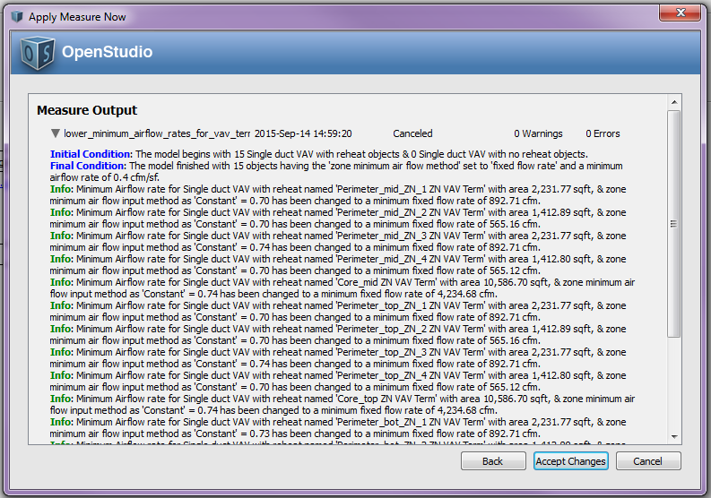

1. **Large Office**

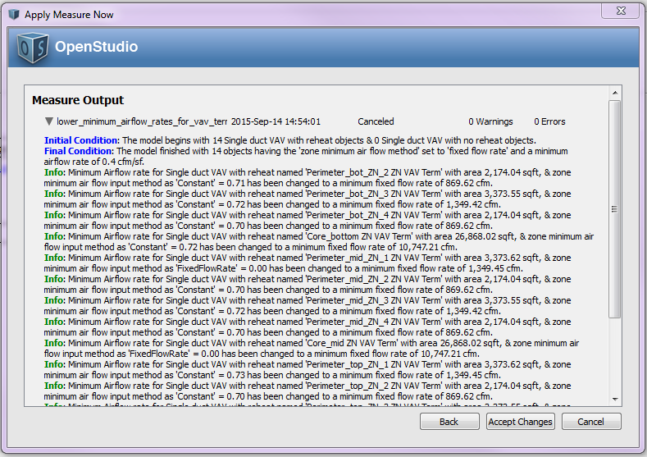

1. **Primary School**

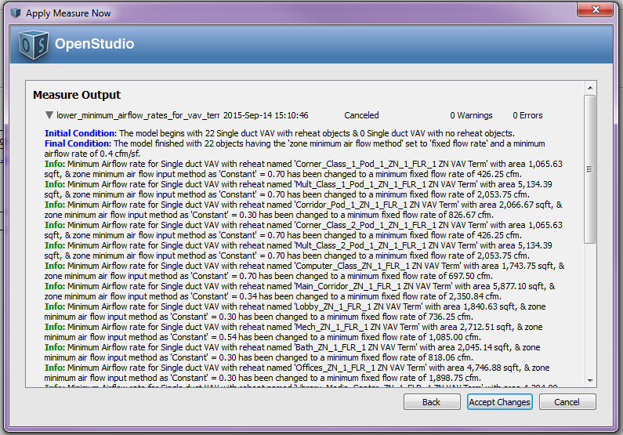

1. **Secondary School**

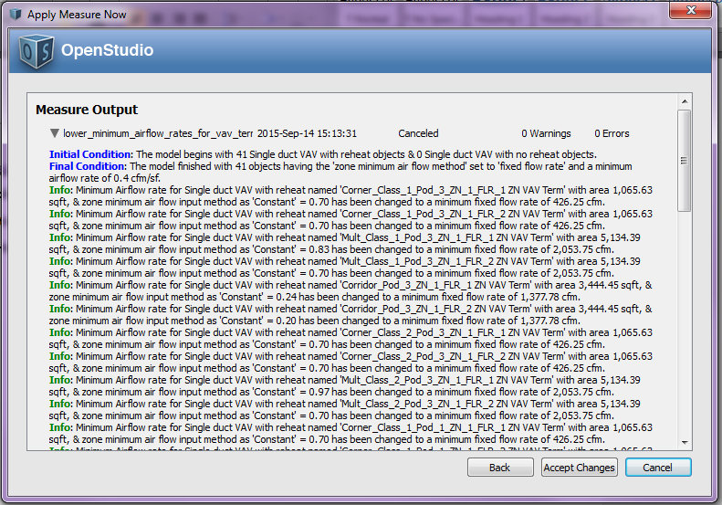

1. **Outpatient Healthcare**
2. **Large Hotel**

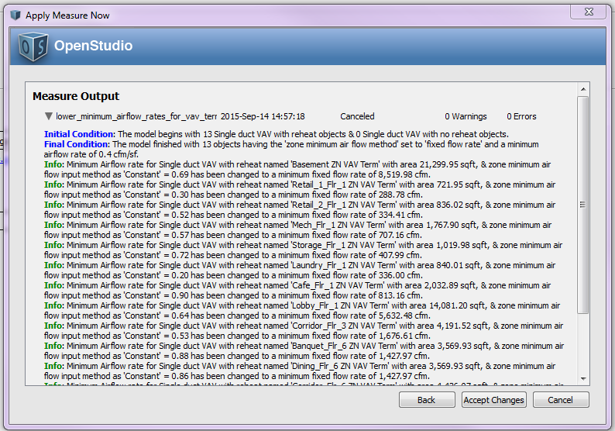

1. **Hospital**

**This measure does not apply to:**

1. **Mid Rise Apartment**
2. **High Rise Apartment**
3. **Small Office**

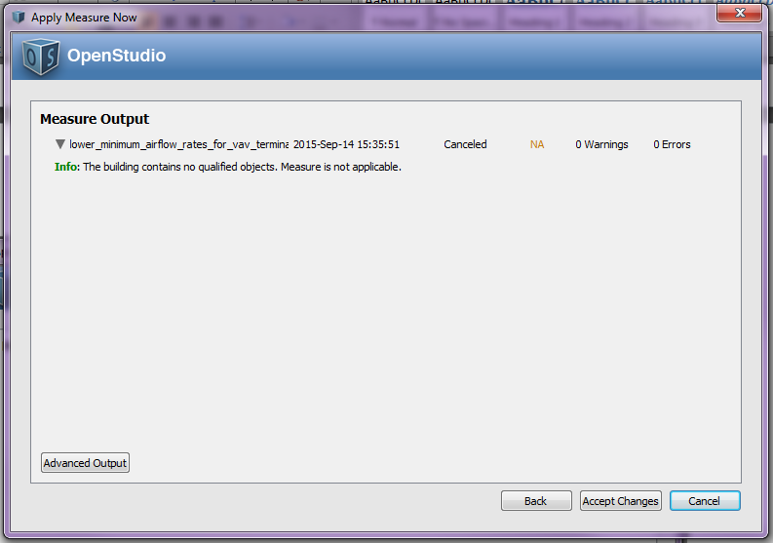

1. **Full Service Restaurant**
2. **Quick Service Restaurant**
3. **Stand Alone Retail**
4. **Strip Mall**
5. **Warehouse (non-refrigerated)**
6. **Small Hotel**

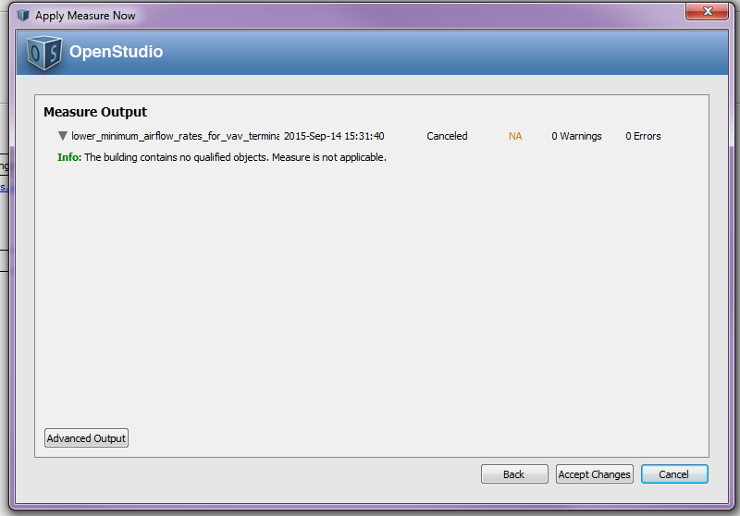

**Test results:**

The delivered measure will include screen shots of the initial, final and info messages as well as screen shots of the OS Application UI showing the object modifications.